Lecture 03 – Homework 50 points. ( Homework B)

Implement the queries below using the db01 database

Work independently.

Put your queries into a submission file per earlier instructions. Name the file ‘Homework03.txt’

Use db01 for this homework.

Note – For full credit ( in addition to proper output)

* Follow the column naming exactly as specified.
* Be sure to follow the format rules we have talked about in class.
* Be aware that I may test your answers with a different data set. IE the correct answer is a query that returns the proper answer for any data set. Not just one that returns a proper answer for the data set provided.

As always the format of the provided output is what I am expecting to see in your output. The exact values, num row, etc will be different.

The Bold text is what you should show for column names.

1 – **building room_number** for all Rooms in the system. ( Note room_number not roomnum)   
 Order By roomNumber, building

2 - **building room_number capacity**  For all rooms with capacity between 10 through 15 inclusive

3 – **attendees** For the DB Issues meeting ( By attendees I mean the name of the Employee)

Order by attendee name

4 – **starttime duration purpose** for all of Max’s meetings Sort with earliest meeting date at the top of the list

5 – **starttime duration purpose building roomnum** for all meetings Alice is attending. Sort by Purpose and StartTime. For purpose, sort in reverse order ( Staff at top) For starttime order with earliest data at top.

**6 – name phone** For all employees. Sort by employee name. ‘A’ at the top of the list.

7 – **organizer_name purpose building room_number meetingReason, startTime, duration** for all meetings owned by Alice Sort by starttime ( most recent data at top) ( note use of organizer_name and room_number )

8 – **name phone**  for all employees whose phone number begins with ‘72’ order by name

9 – **organizer_name homephone** for every meeting organizer order by organizer_name.

( Note – based on what we have talked about in class, you will have to present multiple lines for each organizer. If you want to read ahead and present only one line per organizer, feel free to have fun)

10 – **Building RoomNumber StartTime** for every meeting order by start time, roomnum ;

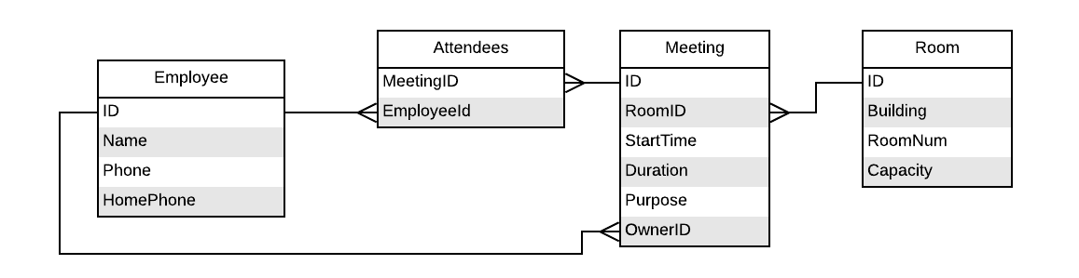

**Expected output** Note – for problem #9 I show two possible solutions.

Student Name

#1

building | room_number

----------+-------------

A | 101

B | 101

A | 102

B | 102

A | 103

A | 104

B | 104

B | 201

B | 202

(9 rows)

#2

building | room_number | capacity

----------+-------------+----------

A | 101 | 10

(1 row)

#3

attendees

-----------

Albert

Alice

Mark

Martha

(4 rows)

#4

starttime | duration | purpose

---------------------+----------+-----------------

2018-03-07 11:30:00 | 90 | HR Presentation

2018-03-09 09:30:00 | 60 | DB Issues

2018-03-17 11:00:00 | 90 | Sales

(3 rows)

#5

starttime | duration | purpose | building | roomnum

---------------------+----------+-----------------+----------+---------

2018-03-04 09:30:00 | 60 | Staff | A | 101

2018-03-11 09:30:00 | 60 | Staff | A | 101

2018-03-18 09:30:00 | 60 | Staff | A | 101

2018-03-25 09:30:00 | 60 | Staff | A | 101

2018-03-15 09:30:00 | 60 | Post Mortem | B | 201

2018-03-07 11:30:00 | 90 | HR Presentation | B | 202

2018-03-09 09:30:00 | 60 | DB Issues | B | 201

(7 rows)

#6

name | phone

---------+-------

Albert | 7234

Alice | 7233

Ariel | 134

Dan | 4501

Dave | 7229

Jack | 7230

James | 7231

John | 8314

Mark | 7228

Martha | 7232

Max | 3261

Sarah | 4592

Sarah | 7227

Winston | 7248

(14 rows)

#7

organizer_name | purpose | building | room_number | meetingreason | starttime | duration

----------------+------------+----------+-------------+---------------+---------------------+----------

Alice | Staff | A | 101 | Staff | 2018-03-25 09:30:00 | 60

Alice | Staff | A | 101 | Staff | 2018-03-18 09:30:00 | 60

Alice | Staff | A | 101 | Staff | 2018-03-11 09:30:00 | 60

Alice | Team Build | A | 102 | Team Build | 2018-03-07 09:30:00 | 60

Alice | Staff | A | 101 | Staff | 2018-03-04 09:30:00 | 60

(5 rows)

#8

name | phone

---------+-------

Albert | 7234

Alice | 7233

Dave | 7229

Jack | 7230

James | 7231

Mark | 7228

Martha | 7232

Sarah | 7227

Winston | 7248

(9 rows)

#9

organizer_name | homephone

----------------+-----------

Alice | 341

Alice | 341

Alice | 341

Alice | 341

Alice | 341

Ariel | 336

Dan | 335

Jack | 342

Winston | 333

Winston | 333

Winston | 333

(11 rows)

#9 Optional answer

organizer_name | homephone

----------------+-----------

Alice | 341

Ariel | 336

Dan | 335

Jack | 342

Winston | 333

(5 rows)

#10

building | roomnum | starttime

----------+---------+---------------------

A | 101 | 2018-03-04 09:30:00

A | 103 | 2018-03-04 09:30:00

A | 102 | 2018-03-07 09:30:00

B | 202 | 2018-03-07 11:30:00

B | 201 | 2018-03-09 09:30:00

A | 101 | 2018-03-11 09:30:00

B | 201 | 2018-03-15 09:30:00

A | 104 | 2018-03-17 11:00:00

A | 101 | 2018-03-18 09:30:00

A | 103 | 2018-03-18 09:30:00

A | 101 | 2018-03-25 09:30:00

(11 rows)